**Practice Assignment On SQL Queries and Joins**

**Table Creation:**

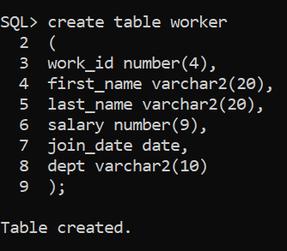

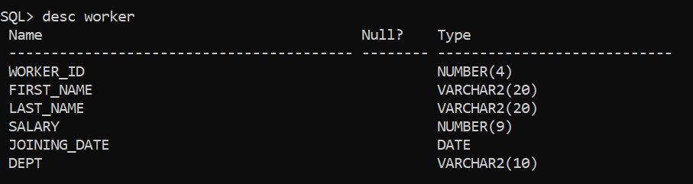

**Inserting Data:**

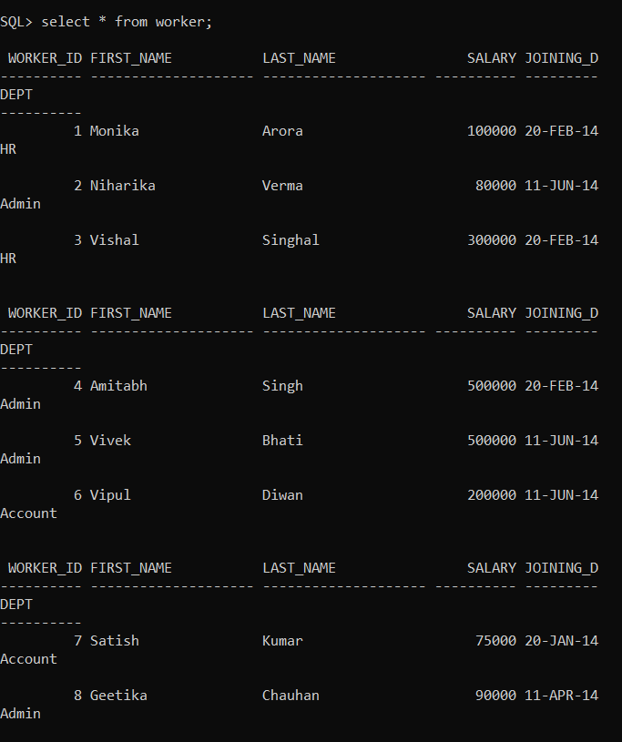

Q-1. Write an SQL query to fetch “FIRST_NAME” from the Worker table using the alias name <WORKER_NAME>.

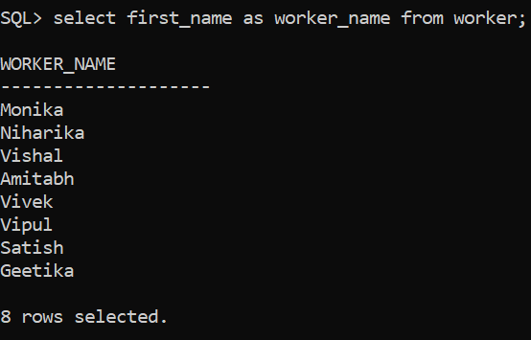

Command: **select first_name as worker_name from worker;**

Q-2. Write an SQL query to find the position of the alphabet (‘a’) in the first name column ‘Amitabh’ from the Worker table.

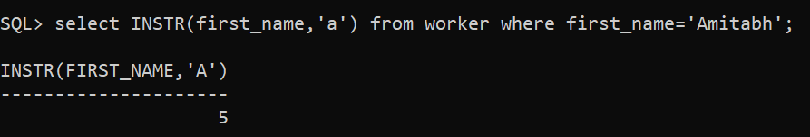

Q-3. Write an SQL query to print the FIRST_NAME from the Worker table after replacing ‘a’ with ‘A’.

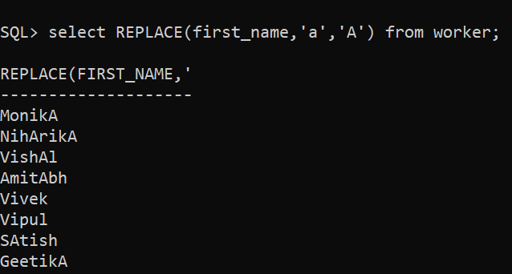]

Q-4. Write an SQL query to print all Worker details from the Worker table order by FIRST_NAME Ascending.

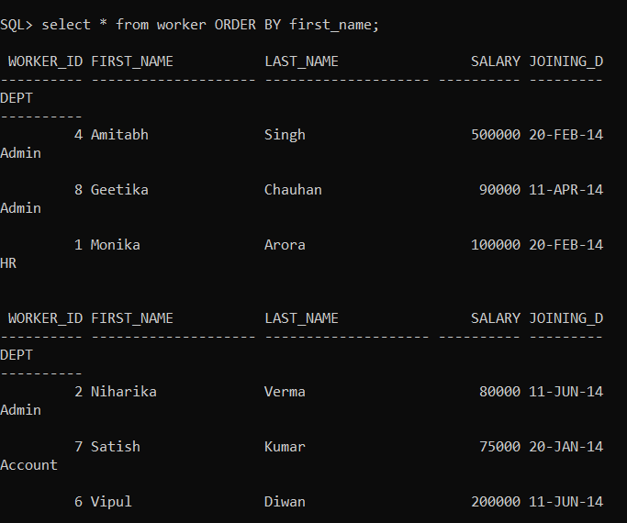

Q-5. Write an SQL query to print all Worker details from the Worker table order by FIRST_NAME Ascending and DEPARTMENT Descending.

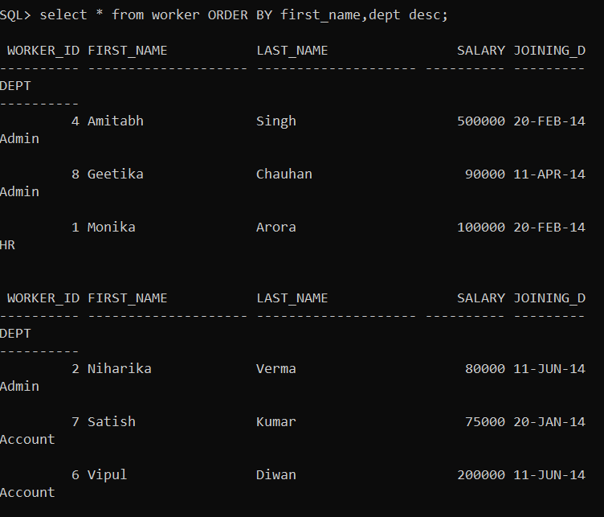

Q-6. Write an SQL query to print details for Workers with the first name as “Vipul” and “Satish” from the Worker table.

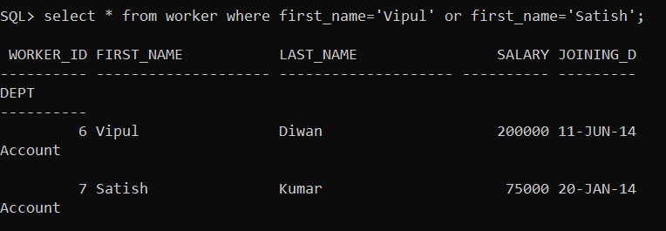

Q-7. Write an SQL query to print details of Workers with DEPARTMENT name as “Admin”

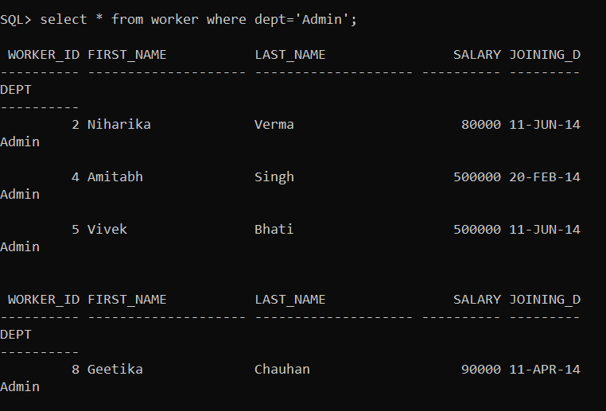

Q-8. Write an SQL query to print details of the Workers whose FIRST_NAME contains ‘a’

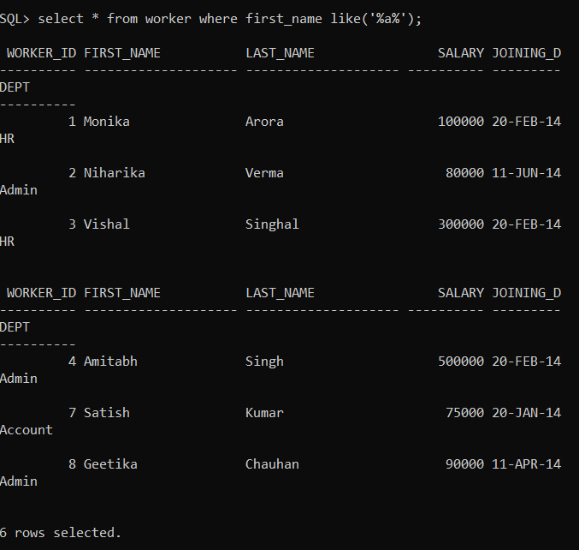

Q-9. Write an SQL query to print details of the Workers whose SALARY lies between 100000 and 500000.

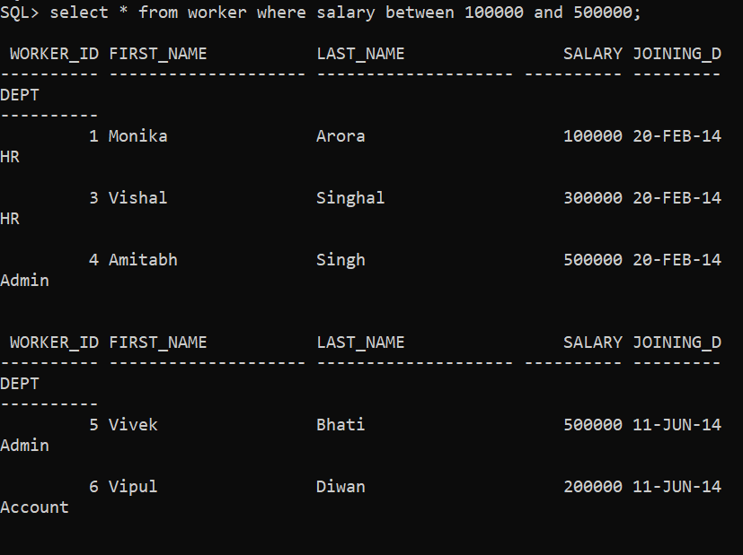

Q-10. Write an SQL query to print details of the Workers whose FIRST_NAME ends with ‘h’ and contains six alphabets.

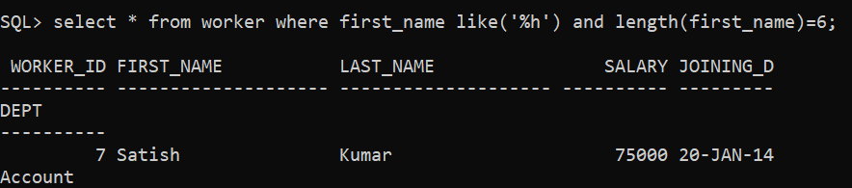

Q-11. Write an SQL query to print details of the Workers who have joined in Feb’2014.

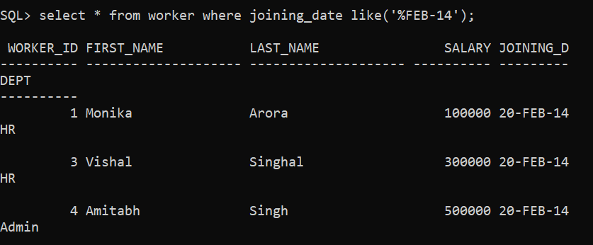

Q-12. Write an SQL query to fetch worker names with salaries >= 50000 and <= 100000.

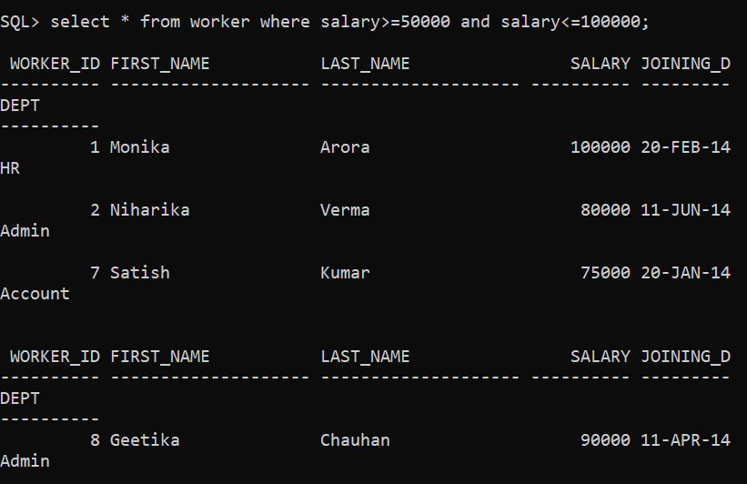

Q-13. Write a SQL query to find the salesperson and customer who reside in the same city. Return Salesman, cust_name, and city

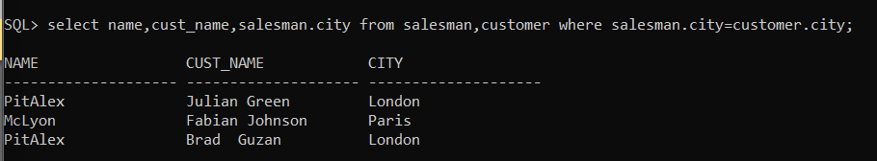

Q-14. Write a SQL query to find the salesperson(s) and the customer(s) he represents. Return Customer Name, city, Salesman, and commission.

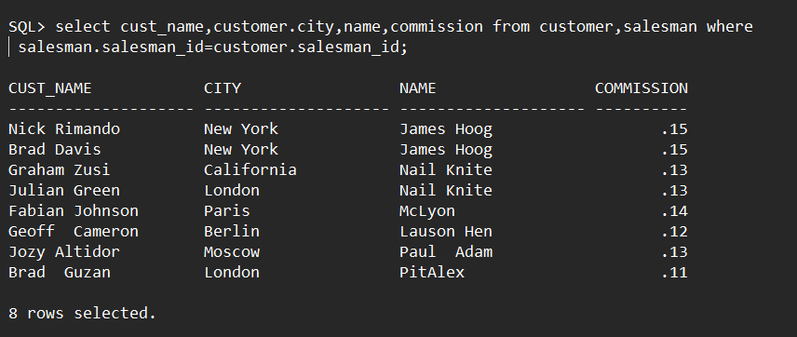

Q-15. Write a SQL query to find salespeople who received commissions of more than 12 percent from the company. Return Customer Name, customer city, Salesman, and commission.

